**Functional Specification for a Simple Automatic Teller Machine (ATM)**

**Introduction**

The Simple ATM allows account holders to make deposits to and withdraw funds from any accounts held at any branch of the Bank .

**Business Context**

Account Holder: a person or organization that creates one or more accounts. Only the account holder is authorized to deposit or withdraw money from these accounts. Only the account holder is authorized to close these accounts.

Account: A record of an amount of money owned by the account's holder, but held by the bank.

**Functional Requirements**

The Simple ATM only requires two use cases:

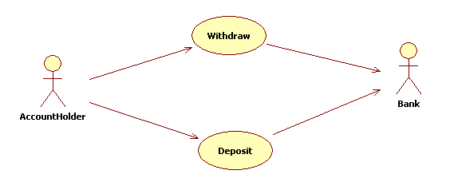

**UC1: Withdraw**

**Actors:** *Account holder and bank* **Description:** *Enables account holder to withdraw funds from an account held at a bank***Priority:** *high* **Risk:** *medium* **Scenarios:  
 ��Main Scenario:** *Success*

AccountHolder: inserts card  
ATM: asks for PIN  
AccountHolder: enters PIN  
ATM: asks for source account  
AccountHolder: specifies source account  
ATM: asks for amount to be withdrawn  
AccountHolder: specifies amount  
ATM: requests account to be debited  
Bank: debits account  
ATM: dispenses cash

**��Alternate Scenario 1:** *Insufficient funds in account* **��Alternate Scenario 2:** *Insufficient funds in dispense*

**UC2: Deposit**

**Actors:** *Account holder and bank* **Description:** *Enables account holder to withdraw funds from an account held at a bank***Priority:** *high* **Risk:** *medium* **Scenarios:  
 ��Main Scenario:** *Success*

AccountHolder: inserts card  
ATM: asks for PIN  
AccountHolder: enters PIN  
ATM: asks for destination account  
AccountHolder: specifies destination account  
ATM: asks for amount to be deposited  
AccountHolder: specifies amount  
ATM: asks for deposit envelope  
AccountHolder: places deposit envelope in slot  
ATM: requests account to be credited  
Bank: credits account

**Non-Functional Requirements**

**Usability**

**Reliability**

**Performance**

**Supportability**

**Implementation**

**Interfaces**

**Operation**

**Packaging**

*Who installs the system? How many installations are there?*